🌟 1. Identifiers in Java (Very Simple Explanation)
An identifier is just a name that you give to things in Java.
Java needs names for many things, and all those names are called identifiers.
✔ Identifier = Name
✔ Name = Identifier
Both mean the same.

🌟 2. Places Where Identifiers Are Used
Identifiers can be used for naming:
1️⃣ Class names
class Student { }
2️⃣ Variable names
int age = 20;
3️⃣ Method names
void printDetails() { }
4️⃣ Interface names
interface Shape { }
5️⃣ Package names
package com.example;
6️⃣ Object names (references)
Student s = new Student();
7️⃣ Labels (rarely used)
start:
for(int i = 0; i < 5; i++) { }
Anywhere you give a name → that name is called an identifier.

🌟 3. Basic Identifier Rules

✔ Identifiers cannot start with a digit.
Example:
❌ 1value is invalid.

✔ You may use digits after the first character.
Examples:
✔ value1
✔ v1
✔ age2025

✔ Allowed first characters:
A–Z, a–z, _, $
Examples:
✔ _temp
✔ $price

❌ Not allowed anywhere:
Spaces, symbols like @, #, -, and Java keywords (class, int, etc.)

🌟 4. FIRST CHARACTER RULE (Very Strict)
As the first character, Java allows ONLY:
✔ Letters (A–Z, a–z)
✔ Underscore _
✔ Dollar sign $
❌ NO OTHER SYMBOL is allowed as the first character.
Examples of invalid identifiers:
- @name ❌
- #value ❌
- -temp ❌
- *data ❌
- &x ❌
Only _ and $ are acceptable symbols at the beginning.

🌟 5. AFTER the First Character — What Is Allowed?
After the first character, Java allows ONLY:
✔ Letters → A–Z, a–z
✔ Digits → 0–9
✔ Underscore → _
✔ Dollar sign → $
❌ NO OTHER SYMBOLS are allowed even after the first character.
Examples of invalid identifiers:
- name@ ❌
- age#1 ❌
- val-ue ❌
- price% ❌
- ab&cd ❌
Symbols like:
@ # % & * - ! + /
are not allowed anywhere inside identifiers.

🌟 6. FINAL SIMPLE RULE

✔ Allowed ANYWHERE inside an identifier:
- Letters (A–Z, a–z)
- Digits (0–9, but NOT at start)
- _
- $

❌ NOT Allowed ANYWHERE:
Symbols such as:
@ # % ^ & * - + ! ~ / ? . , ; : |
None of these can appear in a Java identifier.

7. No whitespace allowed in identifiers
You cannot use spaces inside an identifier.
❌ first name
✔ firstName

8. No special symbols allowed except _ and $
Symbols like:
@ # % ^ & * - + / ? ! . , ; :
are NOT allowed anywhere in an identifier.

9. Identifiers can be of any length
Java does not put a limit on the number of characters.
✔ thisIsAReallyLongIdentifierNameAndItIsStillValid
But long names are not recommended.

10. Unicode characters are allowed
Java identifiers can technically use Unicode letters from other languages.
✔ café
✔ 变量
✔ пример
(BUT in real projects we never do this.)

11. You should use meaningful names
This is good practice, not a compiler rule.
❌ a, b, c1
✔ studentName, totalMarks, employeeSalary

12. Identifiers cannot have operators
You cannot use:
+ - * / % = < >
❌ num+1
❌ value=10

13. Identifiers cannot be literals
You cannot use values as names:
❌ 100 = x;
❌ true = flag;

14. Two identifiers cannot be the same in the same scope
This means you cannot declare a variable with the same name twice:
int age;
int age; // ❌ not allowed

✅ Java Reserved Words (53)
Java has 53 reserved words.

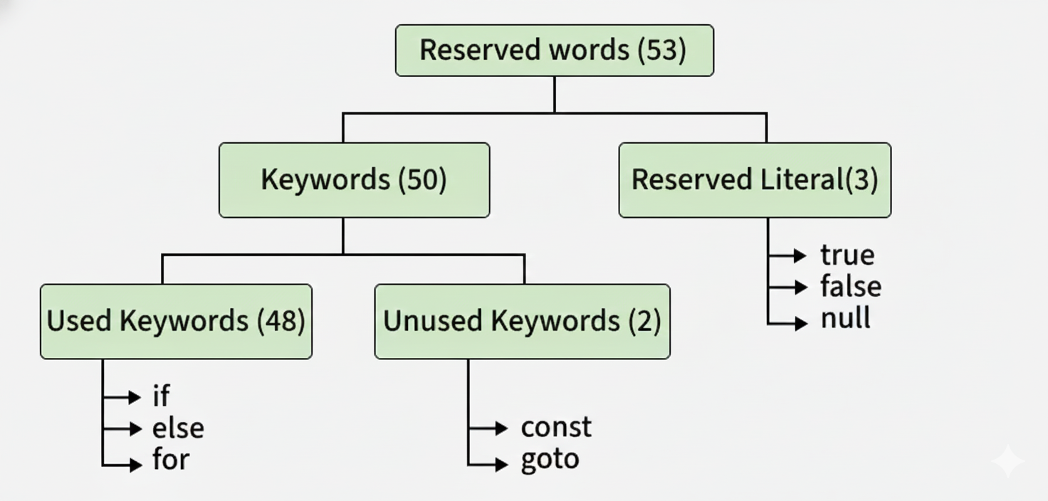

1️⃣ Keywords (50)
These are actual words used in Java programs.

✔ Used keywords = 48
These are keywords we use daily in programs.

✔ Unused keywords = 2
These exist but Java does not use them:
- goto
- const
Java only reserved these so no one will use them as variable names.

2️⃣ Reserved Literals (3)
These look like keywords but represent values:
Literal | Meaning
true | boolean value
false | boolean value
null | default value for object reference

✅ Reserved Words Classification
To make learning easy, Java keywords are grouped.

A. Data Type Keywords (8)
byte, short, int, long, float, double, char, boolean
Used to declare variable types.

B. Flow Control Keywords (11)
if, else, switch, case, default,
for, do, while,
break, continue, return
Used to control program flow.

C. Modifier Keywords (11)
public, private, protected,
static, final, abstract,
synchronized, native,
strictfp, transient, volatile
These modify:
- methods
- variables
- classes
Example: public static final int x = 10;

D. Exception-Handling Keywords (6)
try, catch, finally,
throw, throws, assert

E. Class-Related Keywords (6)
class, package, import,
extends, implements, interface
Used for OOP + organizing code.

F. Object-Related Keywords (4)
new (create object)
instanceof (check type)
this (current object)
super (parent class reference)

Other Important Keyword
void — return type for methods that do not return value

✅ Important Notes

✔ All reserved words start with lowercase letters.
Examples:
class, public, int, for

✔ All class and interface names should start with uppercase.
Examples:
Student, Employee, ProductService

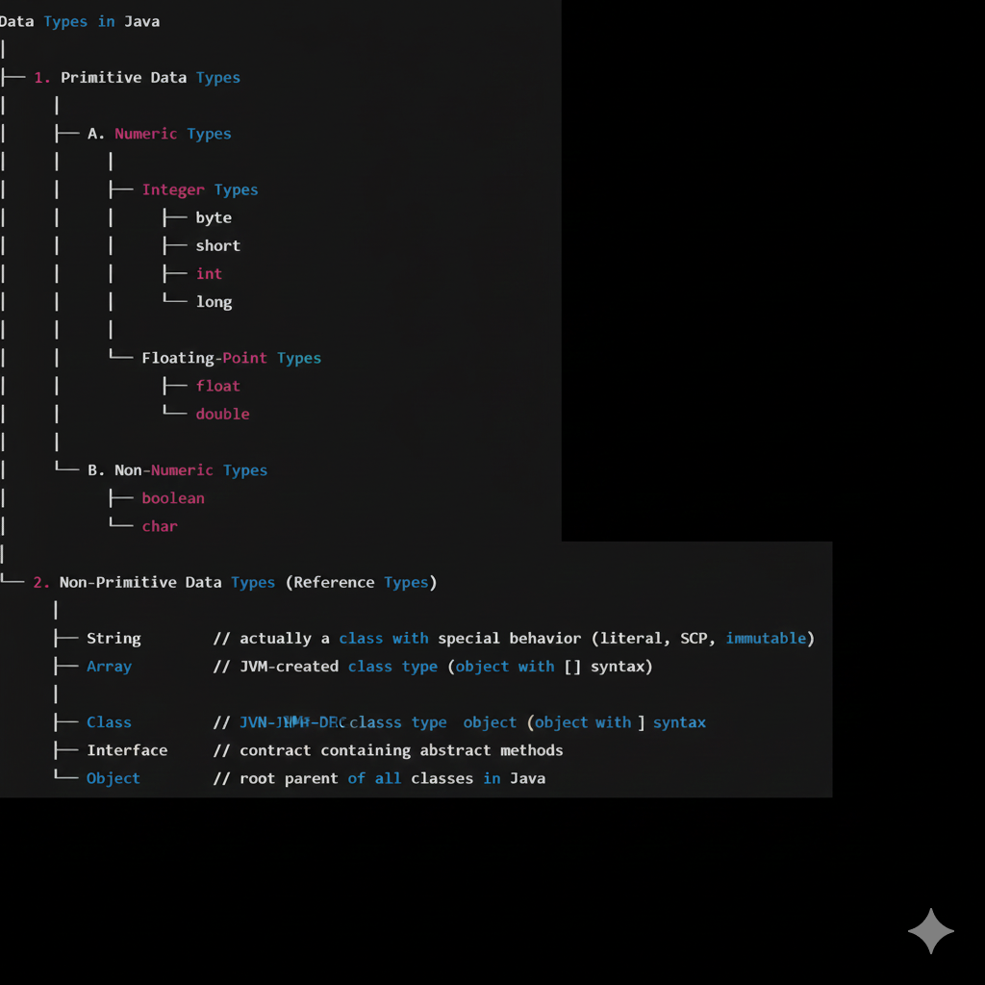

🔶 1. What Are Data Types?
Data types define:
- what kind of value a variable can store
- how much memory it needs
- what operations can be performed on that value
Because Java is a statically/strictly typed language,
every variable’s data type must be known at compile time.

🔶 2. Why Data Types Need Type Checking
Before running the program, the compiler checks:
- Does the value fit into the datatype?
- Is the literal treated as int or double by default?
- Will any conversion cause data loss?
- Are boolean values only true/false?
This verification is called:

⭐ TYPE CHECKING (a sub-topic of Data Types)
Without proper type checking, Java would lose memory safety, accuracy, and reliability.

⭐ 4. Primitive Data Types (Detailed + Type Checking Included)
Below is a clean table:
Type | Size | Default | Notes
byte | 1 byte | 0 | often used in streams
short | 2 bytes | 0 | rarely used
int | 4 bytes | 0 | default integer type
long | 8 bytes | 0L | literal must end with L
float | 4 bytes | 0.0f | literal must end with f
double | 8 bytes | 0.0d | default floating type
char | 2 bytes | '\u0000' | Unicode UTF-16
boolean | JVM-dependent | false | only true/false

⭐ A) Integer Types (byte, short, int, long)

✔ Key Rules with Type Checking

1️⃣ Literal integers are always int by default
long x = 10000000000; // ❌ CE
long x = 10000000000L; // ✔

⭐ Root Cause: Java treats ALL whole number literals as int by default
When you write:
10000000000
Java DOES NOT see this as a long.
Java sees it as an int literal.
But the number 10000000000 is TOO BIG for int
(int max = 2,147,483,647)
So even before assigning it to long, Java already says:
❌ "Integer literal is too large."
This is why the compiler throws an error, not because of long,
but because the literal itself cannot be stored as int.

⭐ Correct Way: Add L or l to make it a long literal
long x = 10000000000L; // ✔ No error
Because now Java sees the literal as long, not int.

⭐ VERY IMPORTANT RULE (Interview Question)

✔ Integer literals are int by default

✔ Decimal literals are double by default
This is why we need:
- L for long
- F for float
Examples:
long a = 5000; // OK (5000 fits inside int, then converted to long)
long b = 5000000000; // ❌ ERROR (too big for int literal)
long c = 5000000000L; // ✔ Works

⭐ Why does long a = 5000; work but not long b = 5000000000;?
Because:
- 5000 fits in int range → compiler allows
- 5000000000 does NOT fit in int range → compiler error
Even though the variable type is long,
the literal is still first checked as int.
This is the key point.

⭐ Simple Analogy (Very Easy to Remember)
Imagine you have:
- A big container (long variable)
- A small pipe (int literal)
Even if the container is big enough,
if the pipe cannot handle the water amount,
the transfer fails before reaching the container.
Same logic:
- long variable is big
- int literal is the pipe
- if literal doesn't fit into int → ERROR

⭐ Final Explanation (One Line)
Java checks the literal first, not the variable.
Since integer literals are int by default, large numbers cause compile-time errors unless we add ‘L’ to convert them into long literals.

2️⃣ Integer expressions always become int
byte a = 10;
byte b = 20;
// byte c = a + b; // ❌ a+b → int
byte c = (byte)(a + b); // ✔

3️⃣ When values exceed type range → compile error
byte b = 128; // ❌

